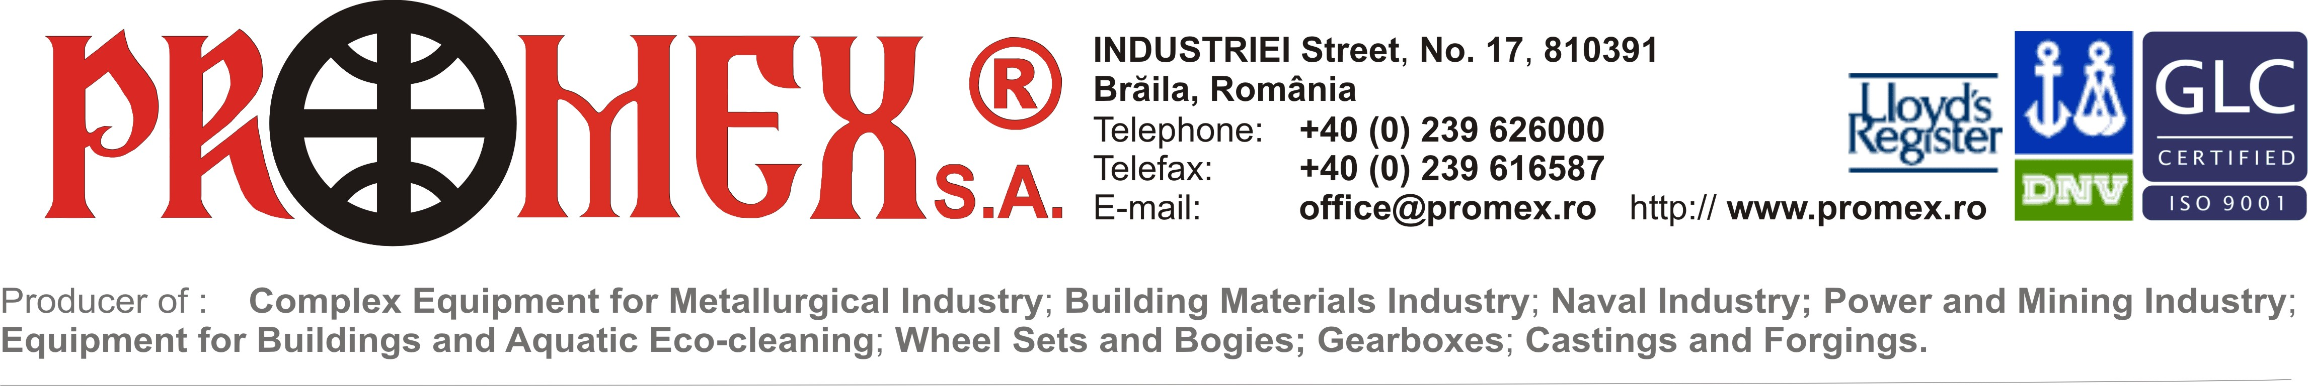
COMPANY PROFILE
S.C. PROMEX S.A.
Braila – Romania

Interest for cooperation: Orders take over in the field of machinery production, including manufacture of steel welded structures, cast parts, forged parts, simple and complex machining, heat treatments, sandblasting, painting, assembly, functional tests, packaging and delivery.

Four production halls are available for the entire heavy industry.

PROMEX is a company certified as to Quality Management System according to ISO 9001-2008 and has Certificates from Germanischer Lloyd, TÜV, SLV München, EWF, DNV, Lloyd’s Register of Shipping (UK) and AFER (Romania) in the field of welding, machining, cast parts and forged parts. In 2008, with over 700 employees, it reached 26, 000, 000 Euro turnover; Percentage for export is 83% and main customers, besides EU and Norway, are USA, Canada, Lebanon and India. Among our permanent customers there are also companies like Arcelor MITTAL, ALRO, Alstom Power, TMK and MECHEL.

PROMEX current scope of supplies and services, with manufacture including as per customers’ documentation, include :
- Complex technological equipment for all production lines in metallurgical industry;
- Equipment for shipbuilding industry: anchor and mooring winches, tugger winches, capstans, deck cranes, anchors, hydraulic cylinders, stern tubes, tillers, shipunloaders;
- Equipment for building materials industry: crushers, presses, bucket and chain conveyors, apron or scraper conveyors, gearboxes, cement mills;
- Installations intended to materials and garbage recycling, including waste incinerator equipment;
- Off-shore installations intended to oil and gas extraction and harbour installations;
- Specific equipment intended for power, oil and mining industries;
- Equipment and machinery for civil and industrial works: crawler and tyre hydraulic excavators, draglines, compacting road rollers, front loaders, floating eco-cleaning equipment intended for cleaning and maintenance of lakes and waterways;
- Cast parts ( steel, cast iron) and forged parts;
- Axles;
- Gearboxes;
- Engineering and technological engineering services.

COMPANY DATA:

Company / Organization: S.C. PROMEX S.A. – Joint Stock Company, private owned
Company tipe : Industry
Address : 17, Industriei Str., 810391, Braila, Romania

COMMUNICATION:

Code: +40 239
Phone: 619400
626000
Fax: 616587
617778
E-mail: office@promex.ro; export@promex.ro; marketing@promex.ro
Website: www.promex.ro
Mailing language: English; German; Romanian.

PROMEX – THE PARTNER OF YOUR DEVELOPMENT!

